Cpp Mini Project

Roll No.: S123

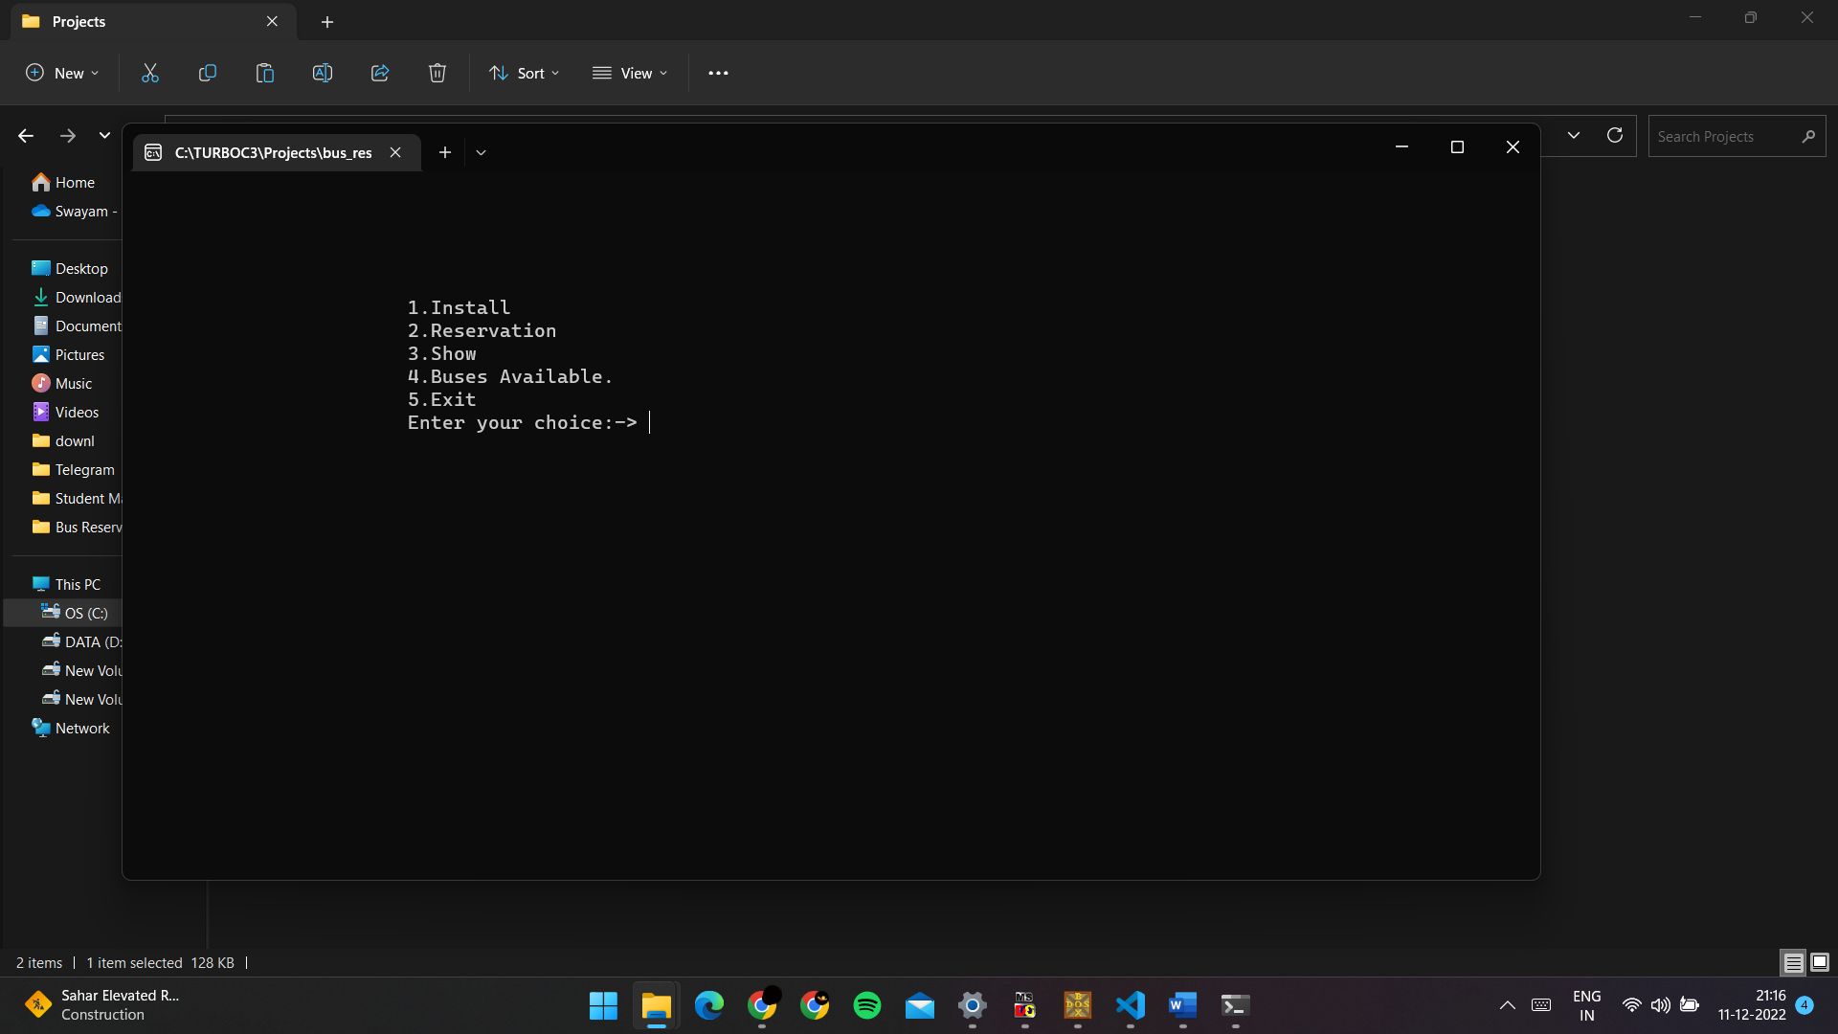

First, apply for a Bus Driver and Bus Number By selecting option 1. Here’s the output

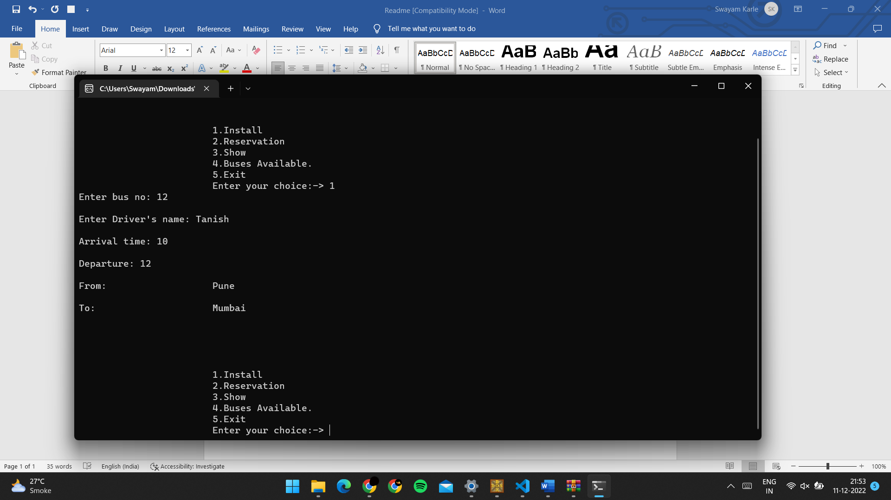

By selecting option 2, we can fill the information for passengers:

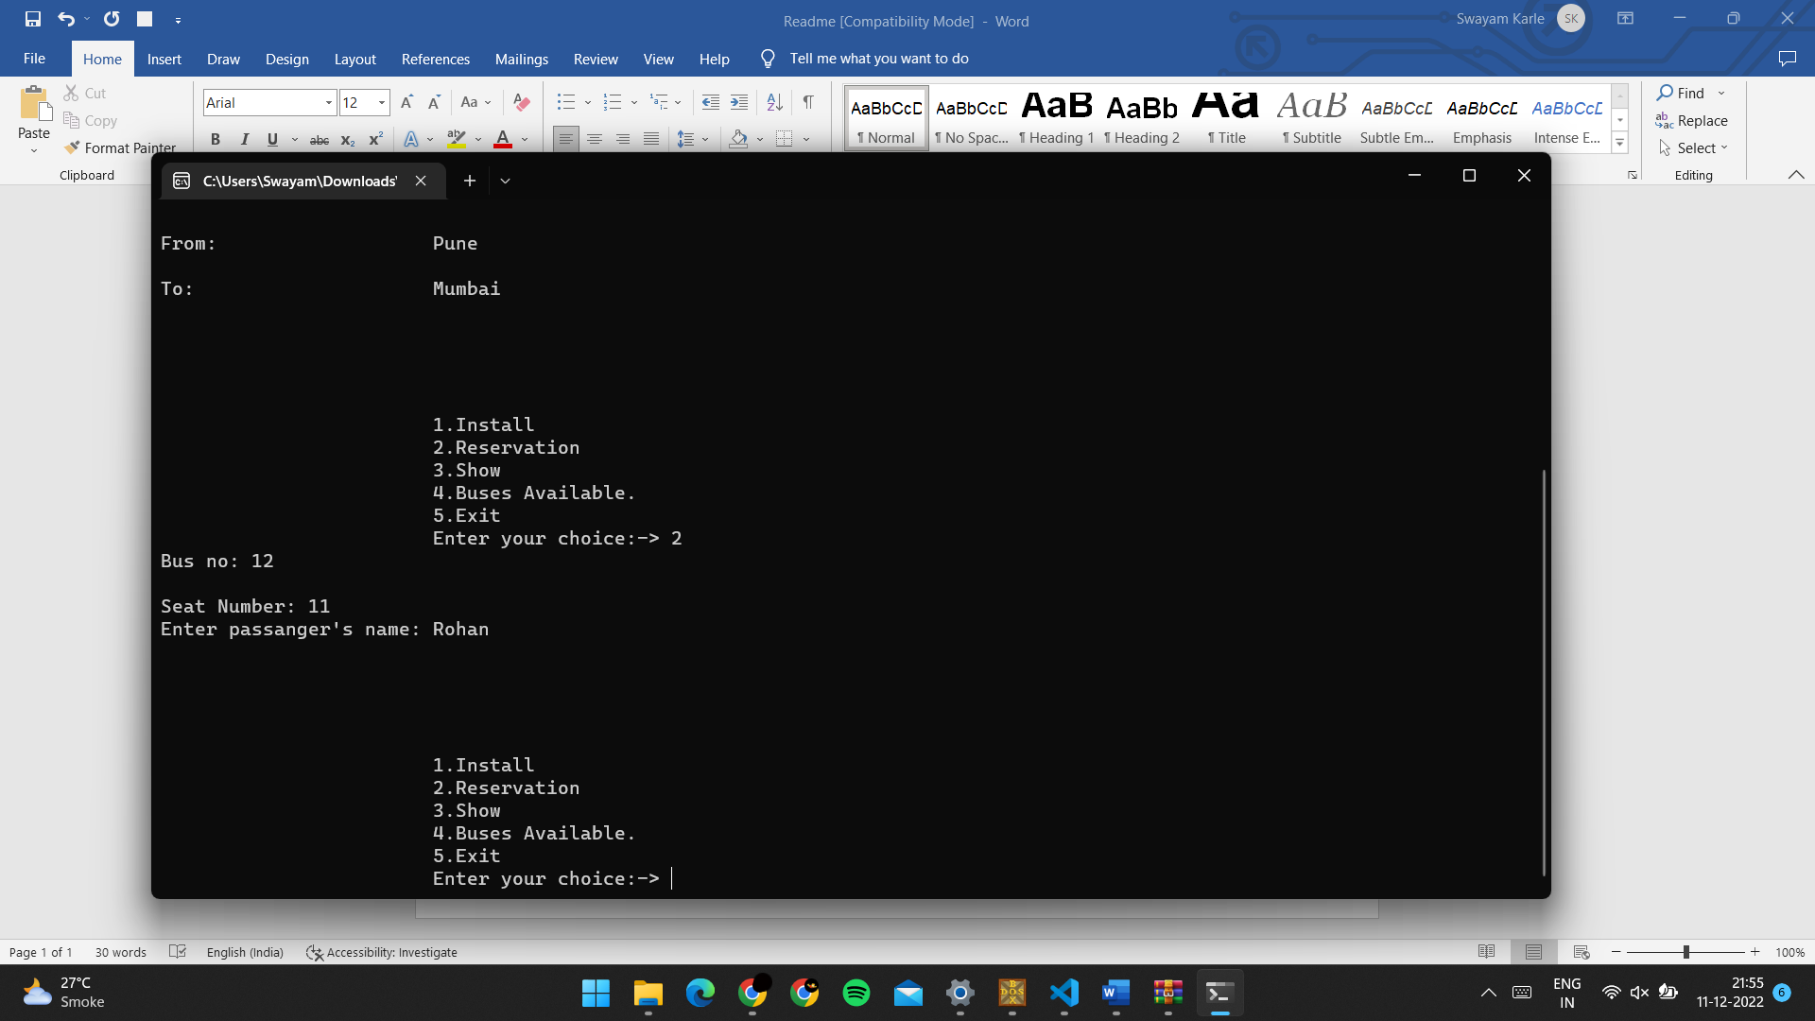

Now selecting option 3, we can see the reservations made, we can do it multiple times:

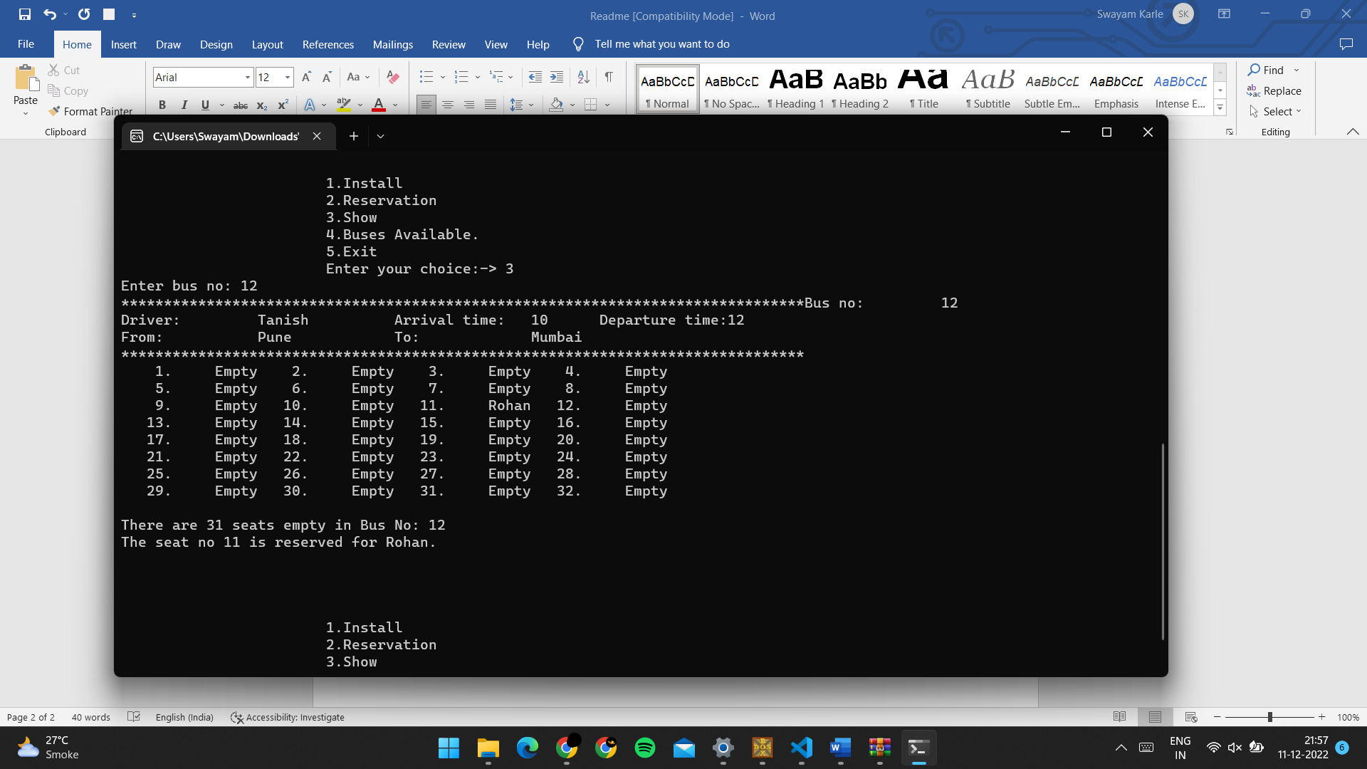

Selecting option 4, we can see the buses available:

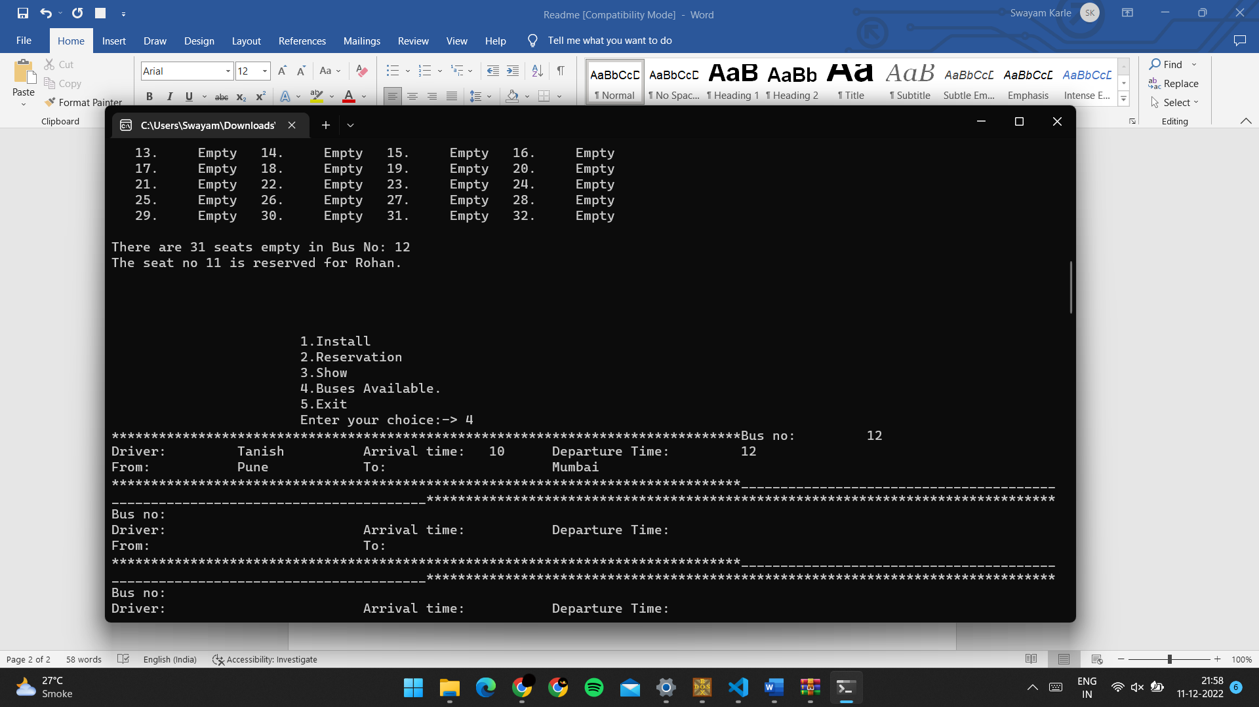

Thank you!